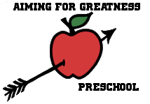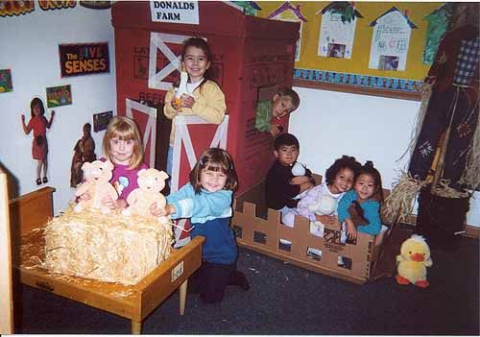

Aiming For Greatness Preschool

1300 Gotham Street

Watertown, NY 13601

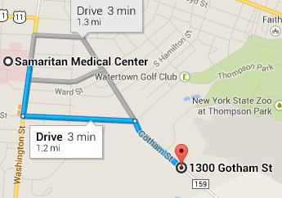

Emily Spink, Owner

License Number: 547132689

**1300 Gotham Street Watertown, NY 13601**

Directions from Samaritan Medical Center

1. Head south on Washington St toward Bowers Ave 0.3 mi

2. Turn left onto Thompson Blvd 0.6 mi

3. Turn right onto Gotham St

Destination will be on the right 0.3 mi

## LC:\Users\Patrick\AppData\Local\Microsoft\Windows\Temporary Internet Files\Content.IE5\3TEM75KU\MM900236244[1].gifcation

Call us to arrange a visit and receive enrollment information!

(315) 804-0592

Or

Visit our website:

aimingforgreatnesspreschool.com

Preschool decreases the academic gap by 20%

Emily Spink

**“Today you are you that is truer than true**

**There is no one alive who is youer than you.”**

**-Dr. Seuss**

* Outdoor/ Gross Motor
* Dramatic Play
* Language and Literacy
* Creative Art
* Music and Movement
* Block Building

# Learning Centers

* Hours
  + Monday, Wednesday and Friday 7:30am to 4:30pm
  + Tuesday and Thursday 7am to noon and 1pm to 5pm
* Children enroll: 30
* Ages: 3 to 5 years old
* Breakfast, Lunch, and Snack depending on session



Cook/Substitute: Mrs. Oarsman



Assistant Teacher: Ms. Freidan

Children are different and unique in their own ways. Even identical twins have different finger prints. As educators, we can’t expect children to learn in the same way. It is important to take time to get to know students as individuals. In my classroom I observe and interact with my students. I create an environment that best suits the children that I teach; building on their strengths and assisting each in overcoming obstacles. I encourage the bonds of friendship in my classroom. I seek out opportunities for children to participate in learning activities with their peers because learning is most enjoyable when you engage with friends

I believe children learn best through play and hands on activities. Therefore, when planning an activity with children, I provide manipulatives they can use to explore. I encourage children to participate in activities to enhance their skills andknowledge. For example, when learning about insects I allowchildren to utilize magnifying glasses as we explore the outdoor living environment.

My goals for each child in my care are simple. I allow children to express their individuality through creative art activities. I believe that art is a medium that supports self-expression. I do not believe in product-based projects. I feel children should feel free to express themselves through various activities in the classroom.

In my classroom I value respect, honesty, creativity, friendship, and kindness. I believe these are critical in achieving happiness. I hope to be a role model to every child and guide him/her in the right direction of true happiness. As an educator I empower children to enjoy life and to live their life to the fullest and to achieve happiness.

~Emily Spink

A.S Degree, Early Childhood

* Supportive Environment
* Hands on Learning
* Free Expression
* Health and Safety

# Our Promise

# Our Program

At Aiming for Greatness Preschool we do not discriminate against race, cultural heritage, national origin, marital status, religion, political beliefs, disability, and sexual orientation.

### My Philosophy